**What is HTTP?**

HTTP stands for HyperText Transfer Protocol.

It is a protocol used to access the data on the World Wide Web (www).

The HTTP protocol can be used to transfer the data in the form of plain text, hypertext, audio, video, XML, JSON and so on.

**Connectionless protocol :**

HTTP is a connectionless protocol.

HTTP client initiates a request and waits for a response from the server. When the server receives the request,

the server processes the request and sends back the response to the HTTP client after which the client disconnects the

connection. The connection between client and server exist only during the current request and response time only.

**Stateless :**  HTTP is a stateless protocol as both the client and server know each other only during the current request.

Due to this nature of the protocol, both the client and server do not retain the information between various requests of the web pages.

**Uniform Resource Locator (URL) :**

A client that wants to access the document in an internet needs an address and to facilitate the access of documents,

the HTTP uses the concept of Uniform Resource Locator (URL).

The Uniform Resource Locator (URL) is a standard way of specifying any kind of information on the inter

The URL defines four parts: method, host computer, port, and path.

**" method://host:port/path"**

e.g:

"http://localhost:8383/demo

**Method:** The method is the protocol used to retrieve the document from a server. For example, HTTP.

**Host:** The host is the computer where the information is stored, and the computer is given an alias name.

Web pages are mainly stored in the computers and the computers are given an alias name that begins with the characters "www". This field is not mandatory.

**Port:** The URL can also contain the port number of the server, but it's an optional field. If the port number is included,

then it must come between the host and path and it should be separated from the host by a colon.

**Path:** Path is the pathname of the file where the information is stored. The path itself contain slashes that separate the

directories from the subdirectories and files.

**HTTP Request / Response :**

The World Wide Web is about communication between web clients and web servers.

Communication between clients and servers is done by requests and responses:

**A typical HTTP request / response circle:**

1. The browser requests an HTML page. The server returns an HTML file.

2. The browser requests a style sheet. The server returns a CSS file.

3. The browser requests an JPG image. The server returns a JPG file.

4. The browser requests JavaScript code. The server returns a JS file

5. The browser requests data. The server returns data (in XML or JSON).

**XHR - XML Http Request :**

All browsers have a built-in XMLHttpRequest Object (XHR).

XHR is a JavaScript object that is used to transfer data between a web browser and a web server.

The XHR Object is the underlying concept of [**AJAX**](https://www.w3schools.com/whatis/whatis_ajax.asp) and [**JSON**](https://www.w3schools.com/whatis/whatis_json.asp):

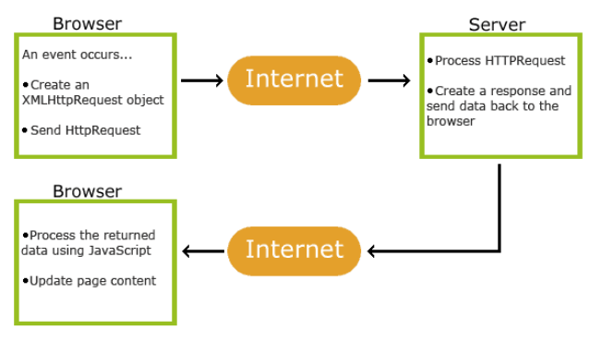

**HTTP Methods :**

**GET**

The GET method is used to RETRIEVE information from the given server using a given URI. Requests using GET should only retrieve data and should have no other effect on the data.

**POST**

A POST request is used to send(CREATE) data to the server, for example, customer information, file upload, etc. using HTML forms.

**PUT**

Replaces(UPDATE) all current representations of the target resource with the uploaded content.

**DELETE**

Removes (DELETE) all current representations of the target resource given by a URI.

**Https:**

**What is Domain Name?**

A domain name is a unique address used to access a website.

Usually, it consists of a website name and a domain name extension.

e.g. abc.com

here, “abc” is website name.

“.com” is extension.

A domain name is your website’s equivalent of a physical address. It helps users find your site easily instead of using its internet protocol (IP) address. Domain names consisting of a name and an extension are a key part of the internet infrastructure.

How Do Domains Work :

Every website has two main elements – a domain name and a [web hosting server](https://www.hostinger.in/web-hosting). All domain names are linked to their respective IP addresses and point to the specific web servers that host the websites.

When a user enters a domain name into a browser, it looks for the associated IP address through a global network of [Domain Name System (DNS)](https://www.hostinger.in/tutorials/what-is-dns) servers.

Next, the server with the information about the IP address returns it to the web browser, which requests data about the site from the domain’s hosting service. This web server stores all of the website’s data, including its files, database, and HTML code.

Once the host has sent the data back, the web browser converts it into a web page that users can visit.

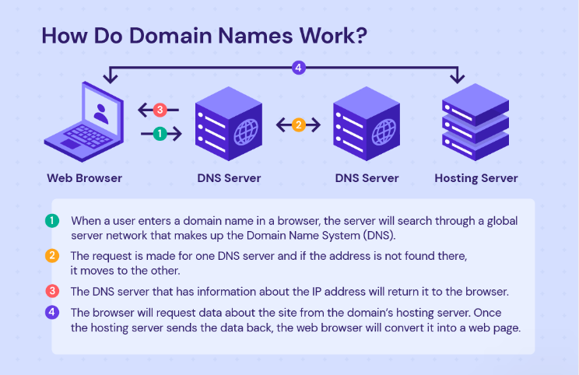

**There are Different Uses of Creating Domain Name :**

**Memorability.** Your audience can technically visit your website without a domain name by entering its IP address. However, since it consists of a string of numbers, it is difficult to remember. Domain names help a website be more accessible to internet users.

**Effective branding.** A well-thought-out domain name will help communicate your project or business in a way that aligns with your brand’s values and mission.

**Credibility.** Websites that use custom domain names are more professional-looking than those with a free domain name, like yourwebsite.websitebuilder.com.

Custom email addresses. Having a domain name lets you create unique and professional [business email](https://www.hostinger.in/business-email) accounts, like name@yourdomain.com. It also makes your presentation consistent throughout different online channels.

**SEO.** A memorable domain name with relevant keywords will positively impact your website’s search engine optimization, improving its rankings on search engines.

**Different Types of Domains :**

Different types of domain names can reveal more information about a website. Here are some of the most common types :

**TLD:** Top-Level Domain

A [top-level domain](https://www.hostinger.in/tutorials/what-is-tld) is a domain extension. [Various TLDs](https://www.hostinger.in/tld) are available online, but [.com domains](https://www.hostinger.in/tld/com-domain) are the most popular, with over [54%](https://www.statista.com/statistics/265677/number-of-internet-top-level-domains-worldwide/) of all websites using them. A popular extension drives high organic traffic as users often write it by default. Other popular choices are .net, [.io](https://www.hostinger.in/tutorials/what-does-io-mean), and [.store TLD](https://www.hostinger.in/tld/store-domain).

However, a less popular extension, such as [.online](https://www.hostinger.in/tld/online-domain), is often less expensive and can make a domain more unique. Other examples of cheap domains include [.tech](https://www.hostinger.in/tld/tech-domain), .site, and .shop. With the increasing number of [new websites created daily](https://dnpedia.com/tlds/daily.php), the popularity of a specific top-level domain might also change in the future.

We can check out the [Internet Assigned Numbers Authority (IANA)](https://www.iana.org/domains/root/db) (<https://www.iana.org/domains/root/db>)  for the official list of all legitimate TLDs.

**ccTLD:** Country-Code Top-Level Domain

**gTLD:** Generic Top-Level Domain

Other Types of Domain : -

**Second-Level Domain :**

A second-level domain (**SLD**) is below TLDs in the domain name hierarchy. An SLD is the section of a domain name located to the left of the last dot. Take www.hostinger.com, for example – hostinger is the SLD, and .com is the TLD.

Some domain name registries use a second-level domain to indicate a specific entity registering. For example, academic institutions in the United Kingdom mostly register websites under .ac.uk.

**“ Subdomain**

A [subdomain](https://www.hostinger.in/tutorials/what-are-subdomains) indicates a separate division from a parent domain that still shares the same servers. There is no need to register a subdomain. Technically, the www of most URLs is a subdomain that shows that a site is part of the world wide web.

The most common reason to create subdomains is to organize and divide web content into separate sections. For example, Google uses developers.google.com to provide specific information for developers.

Another use of a subdomain is to create another website with the same name but in different languages. Take Wikipedia as an example – it has a separate subdomain for each language. It uses en.wikipedia.org for the English version and es.wikipedia.org for the Spanish one.

**“ Free Domain**

Website builders, such as WordPress.com, or content management systems, like Blogger, often offer free domain names for new users. Usually, beginners take this opportunity to create their websites before investing money into them.

A free web address often follows the same structure as subdomains. For example, instead of hostingertutorials.com, the domain would be hostingertutorials.wordpress.com or hostingertutorials.blogspot.com.

Keep in mind that getting a [free domain](https://www.hostinger.in/tutorials/how-to-get-a-free-domain-name) often comes with minimal features and tools.

**Domain purchase / Getting a Domain Name :**

Domain registration is the process of purchasing a domain from a domain name registrar for a specific period. On the other hand, domain name transfer refers to the process of moving a domain from one registrar to another.

Open any of the domain Name service providers.

A popular few are-

<https://godaddy.com/>

<https://www.hosting.co.in/>

<https://www.hostinger.in/>

https://myraah.io/

1. check if your desired name is still available.

Can find the list of legitimate domain name registrars, check the [ICANN database](https://www.icann.org/en/accredited-registrars).( <https://www.icann.org/en/accredited-registrars>)

1. Select your desired domain and continue to checkout.
2. Choose the registration period for your domain
3. Upon payment, access your new account.

Definition: **A top-level domain (TLD), also referred to as a domain extension, is the suffix that follows the domain name in a web address**; the most widely-used is ".com". TLDs are managed by the Domain Name System of the Internet, which controls how domain names are translated into Internet Protocol, or IP, addresses.

**Domain name vs URL :**

domain renewal cost and criteria:

premiun domain :

where to check if not available:

hot to sell domain:

how to tranfer domain:

what is EPP code:

subdomain (What and Why) :

- use to show saple website, inder construction website, template

e.g:

https://demo1.elitesoftwares.co.in/